WORKING/FLOW OF THE PROGRAM:

1 – User sees the home screen:

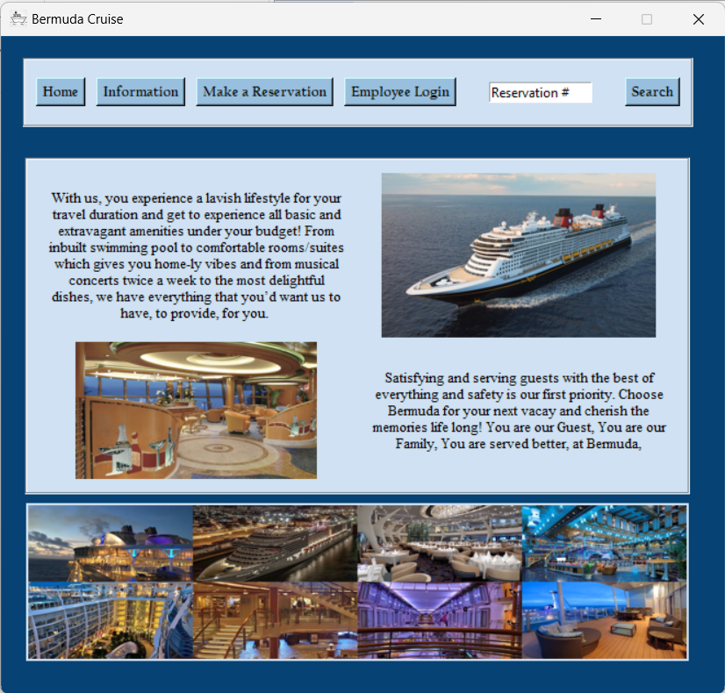

2 – User clicks on ‘Information’:  
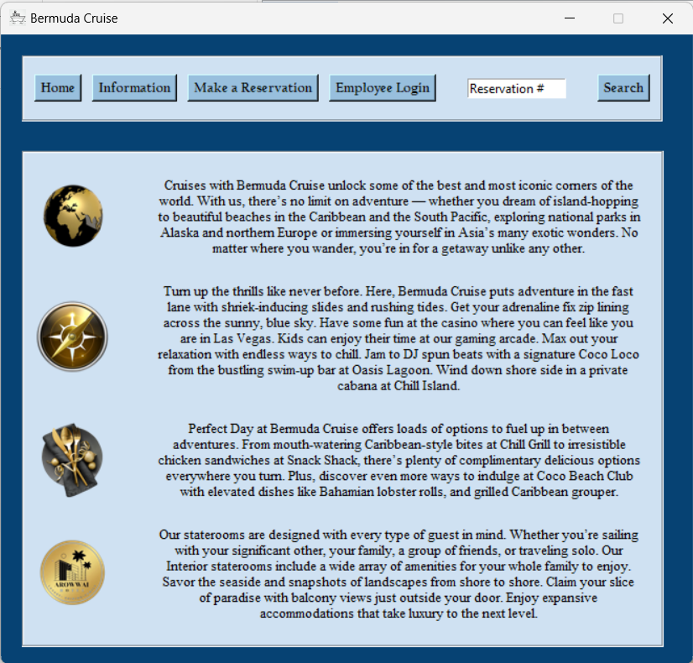

3 – User clicks on ‘Make a Reservation’:

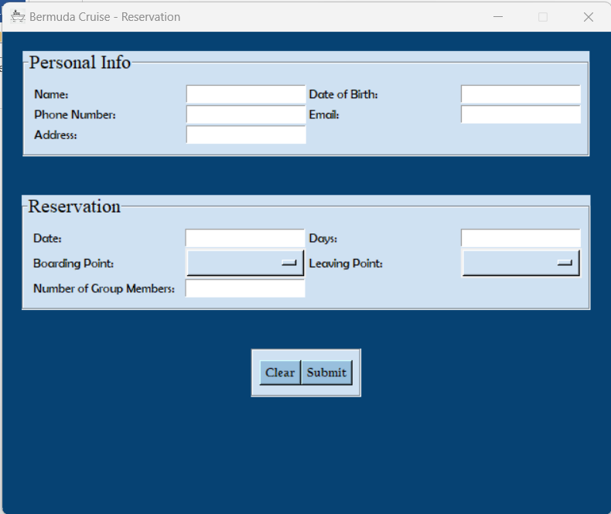

4 – User enters details, then sees ‘Suite & Activity’ screen:

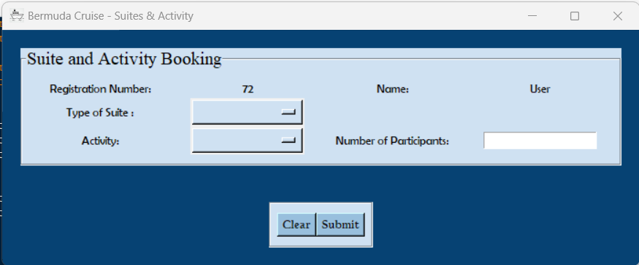

5 – User enters details, then sees ‘Payment’ screen:

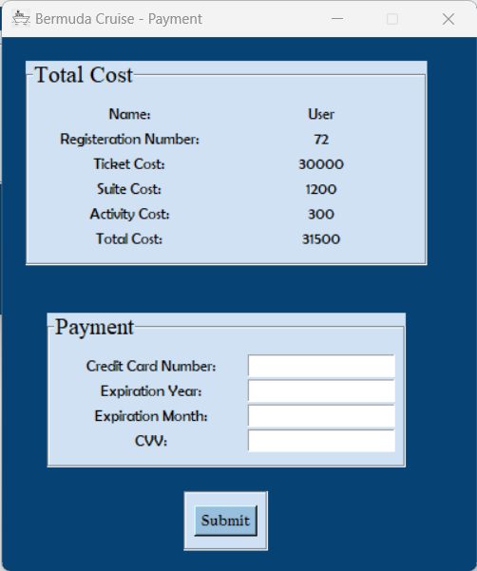

6 – User goes to home screen, searches for their reservation number and sees their information:

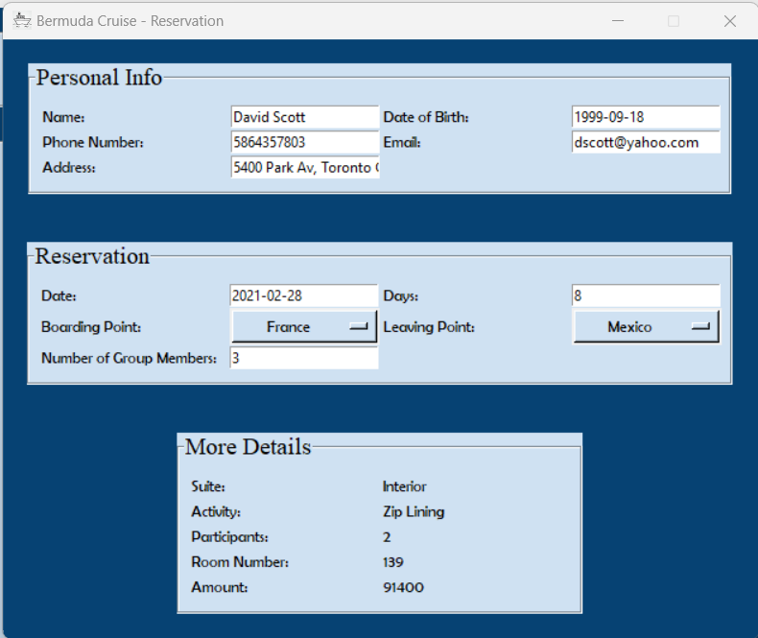

USER’S BOOKING COMPLETED

7 – Employee clicks ‘Employee Login’ on home screen:

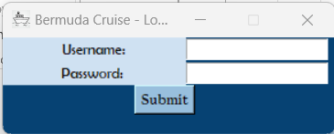

8 – Employee enters username and password, then sees information of customer:  
